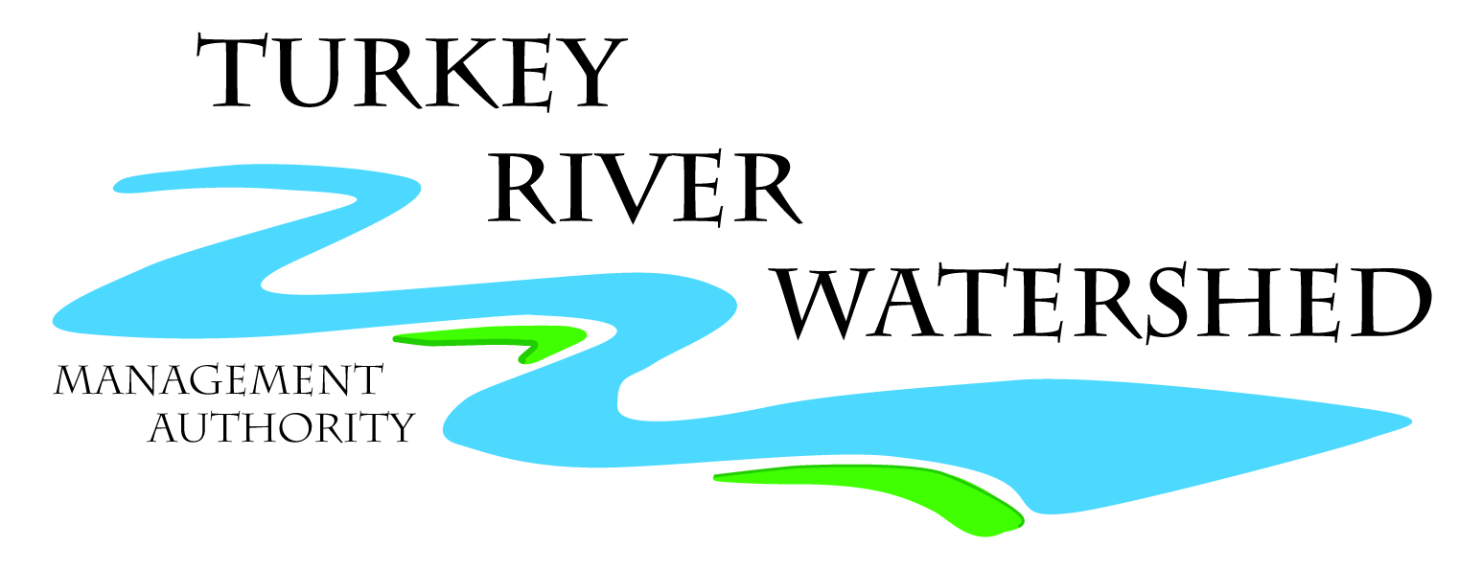
Agenda
Turkey River Watershed Management Authority Meeting
1:00pm Thursday March 24th, 2016
Postville YMCA, 313 W Post St, Postville, IA 52162

- Approval of Agenda - MOTION
- Approval of Minutes from November 19th, 2015 Meeting - MOTION
- Old Business
  - Distribute and Discuss Final Watershed Resiliency Plan
  - Grant Updates
    - Healthy Watersheds Consortium Grant Program
    - Pre-disaster Mitigation Grant/Flood Mitigation Grant Program
    - Water Quality Improvement - IDALS
    - RCPP 2016
  - Otter Creek Update
- New Business
  - Iowa Flood Center – Presentation from Antonio Arenas Armado
  - Source Water Protection - Clermont
- Schedule Next Meeting
- Adjourn - MOTION

TURKEY RIVER WATERSHED MANAGEMENT AUTHORITY BOARD OF DIRECTORS
1:00 pm Thursday, November 19th, 2015
REGULAR BUSINESS MEETING

The regular meeting of the Turkey River Watershed Management Authority Board of Directors was called to order at 1:00 pm on November 19th, 2015 at Postville YMCA, in Postville, Iowa.

MEMBERS PRESENT:
Dan Carolan, Chickasaw County Gerry Ommen, Clayton County SWCD Dan Carolan, City of Lawler
Bill Bennett, Fayette County SWCD Rod Marlatt, Fayette County Chris Hackman, City of Postville
Jennifer Cowsert, City of Elkader Ron McCartney, Clayton County Ron Hyberger, City of Cresco
Bart Wilson, Howard SWCD Mark Kuhn, Winneshiek County Jim Reicks, Chickasaw SWCD
Jan McGovern, Howard County Corey Meyer, City of Calmar Paul Hoeger, City of Maynard
Eric Boehm, City of Wadena Jon Biederman, City of Fayette Jon Biederman, City of West Union

*Phone

*APPROVAL OF AGENDA
**MOVED BY BENNETT, SECONDED BY CAROLAN, CARRIED UNANIMOUSLY.
TO APPROVE AGENDA AS PRESENTED

*APPROVAL OF MINUTES FROM SEPTEMBER 17TH, 2015
**MOVED BY WILSON, SECONDED BY BIEDERMAN, CARRIED UNANIMOUSLY:
TO APPROVE THE MINUTES FROM SEPTEMBER 17TH, 2015 AS PRESENTED.

*OLD BUSINESS

  - Grant Updates – Ross Evelsizer updated the Board on a number of grants that are in progress, past applications, or coming available

    - Tile Outlet Monitoring – Tile outlet monitoring ended in September as most of the tiles dried up. Results from this year’s monitoring efforts were analyzed and used in the TRW Water Resource Plan.
    - Champion Producers Conservation Innovation Grant - RC&D is working with TRW producers to promote champion conservation producers through professional photos and media materials. Part of this outreach includes a webpage at turkeyriver.org/producers.
    - RCPP – The final application for the RCPP for the TRW was withdrawn.
    - NFWF and Leopold Center - RC&D partnered with the Iowa Soybean Association to apply for grants from the National Fish and Wildlife Foundation and the Leopold Center for Sustainable Agriculture. The NFWF grant was successfully awarded and this project will begin in 2016. The Leopold Center Grant is still pending.
  - Field Day with Iowa Corn Growers Association – The field day is scheduled for December 2nd at the Fayette County Fairgrounds.

*NEW BUSINESS
  - Approve Water Resources Plan Components
**MOVED BY BENNETT, SECONDED BY MCGOVERN, CARRIED UNANIMOUSLY: TO APPROVE WATER RESOURCE PLAN COMPONENTS WITH ADDITIONS AND EDITS APPROVED BY THE EXECUTIVE COMMITTEE.

*ADJOURNMENT AT 2:40 PM

**MOVED BY OMMEN, SECONDED BY BOEHM, CARRIED UNANIMOUSLY:
TO ADJUORN REGULAR MEETING AT 2:40 PM

********The next meeting is scheduled for Thursday March 24th, 2016, at 1:00 PM at the Postville YMCA*************

